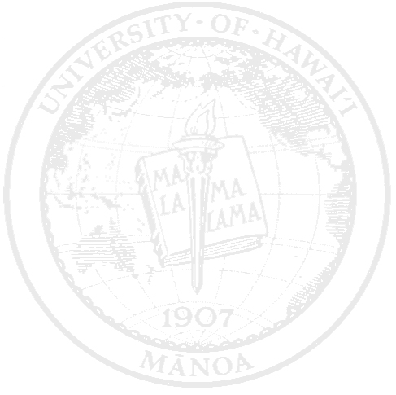
Tami Saito saitotk@hawaii.edu
Objective: | To teach and serve K-6 students in the Hawaii public school system and potentially the upper grade levels.
Education:  Experience:  Additional Experience:  Certification:  Awards:  Skills: | 2012-2014 University of Hawaii at Mānoa Honolulu, HI  - Master’s Degree in Education Technology  Cumulative GPA: 4.0  2010-2012 University of Hawaii at Mānoa Honolulu, HI  - Bachelor’s Degree in Elementary Education  Cumulative GPA: 4.0  2007-2010 University of Maui College Kahului, HI  - Associate of Arts Degree  Cumulative GPA: 3.8+  2003-2007 Henry Perrine Baldwin High School Wailuku, HI  2000-2003 Iao Intermediate School Wailuku, HI  1994-2000 Wailuku Elementary School Wailuku, HI  Fall 2011 – Spring 2012 (Student Teacher, Grade 2)  Wailuku Elementary School Wailuku, HI  - Solo taught for three straight weeks  - Developed and implemented integrated unit and single lesson plans in ALL of the subject areas  - Gained experience in instruction, assessment, and classroom behavior and management  - Utilized the school’s current technologies to create a media-rich learning environment  Spring 2011 (Student Teacher, OP Grade 4)  Kahului Elementary School Kahului, HI  - Developed a integrated unit lesson plan in the subject areas of language arts and music  - Gained experience in instruction, assessment, and classroom behavior and management  - Utilized the school’s current technologies to create a media-rich learning environment  Fall 2011 (Student Teacher, OP Grade 3)  Wailuku Elementary School Wailuku, HI  - Gained experience in instruction, lesson planning, classroom behavior and management  - Learned to develop and implemented integrated lesson plans in the subject areas of language arts and math  - Utilized the school’s current technologies to create a media-rich learning environment  2014 Presented my Master’s Project at the Google Summit  2014 Guest Speaker for a teacher’s PLC  (Introduced Gmail and Google Docs)  2013-present Substitute Teacher  (Taught at Wailuku Elementary, Kahului Elementary, Kamalii Elementary, Iao Intermediate, Maui Waena, and H.P Baldwin High, Grades K-12)  2012-present Assist Maui Youth Philharmonic Orchestra  2011-2013 Assisted Wailuku Elementary & Kahului Elementary School’s Technology and Curriculum Coordinator  - Volunteered at Wailuku Elementary School  (Kindergarten Grade Level)  2009-present Volunteer at Iao Intermediate summer band program  (Grades 6-8)  - Summer Music Program at Doris Todd  (Music Instructor, Grades 3-12)  2008 Volunteered at Harbor Lights  (Afterschool educational program with children)  2007 Music Program at ST. Anthony  (Music Instructor, Grades 6-12)  2007-present Volunteering at Baldwin High School- Band  (Color Guard Instructor, Grades 9-12)  2015 Hawai’i Teacher Standards Board Standard License  Authorized Teaching Field(s): Elementary Education K-6  2010-present Pi Lambda Theta- Beta Zeta Chapter  (Academic Honor Society)  2007-present Dean’s List  2006-2007 Shawnder Yee Memorial Scholarship  Arion Award-Band  Play multiple musical instruments, instrument repair, Artistic, Photography, Video Making, Microsoft Word, Excel, PowerPoint, Integration of curriculum with technology & the arts, and Innovative in working with young children.
Interests:  References: | Band, Arts & Crafts, Photography, Draw & Paint, Technology, Language, and Travel.  References are available upon request.

